**Curtis Motes Warship Warfare Game Design Document**

Player experience goal: They player should feel rushed to get a good score and enjoy the intensity of the random warship appearance and lasers. The experience should be both exciting and suspenseful.

Audience: All ages

Premise of the Game : You are a tank driver trying to meet back up with your fleet.

Objective: Destroy the warship and collect the points as quickly as possible for the highest score. Avoid getting hit by lasers.

Characters and Objects:

Player : Red tank, can move up,down,left,right, fire missiles. Cannot go through walls

Boss: Giant warship, moves up and down across the screen. Fires from any point of its body.

Coin : Gives the player 2500 points

Missile: Fired from player tank. Can hit warship for 1 health damage

Laser: Fired from warship. Can hit player, taking a life

Story: You are an experienced war vet in your tank. Everyone knows the red tank. You’re trying to meet up with your fleet when you are ambushed by a massive enemy warship. With no other option, you must fight.

Aesthetics: Visuals feature a lush grassy area, sand squares, and a castle wall perimeter. The player drives a bright red tank. The enemy is a big brown-red warship. There is no audio in this game.

Gameplay Mechanics: The player controls the red tank. He can move up, down, left, and right, using w,s,a,d, respectively. The player can move through grass and sand and the warship, but not through walls. The player can fire missiles using ‘f’ key. The player must try to dodge oncoming lasers from the warship while firing missiles at it and collecting coins. The game ends if the player hits the warship 10 times or is hit by lasers 3 times. The player’s score will also gradually decrease as play goes on to increase suspense.

Rules: The player can only fire once every 2 seconds. The warship can move through walls. Player’s earn 2000 points for a successful hit on the warship. The player earns 2500 points for collecting a coin. The player does not have to collect all coins to win the game. If the player is hit by a laser, he will lose a life. Upon losing all three lives, the game will end.

**Design process notes**: Originally, I wanted to have two tanks in the game. However, I found this inconvenient for player experience because players would be competing for the keyboard to input their action.

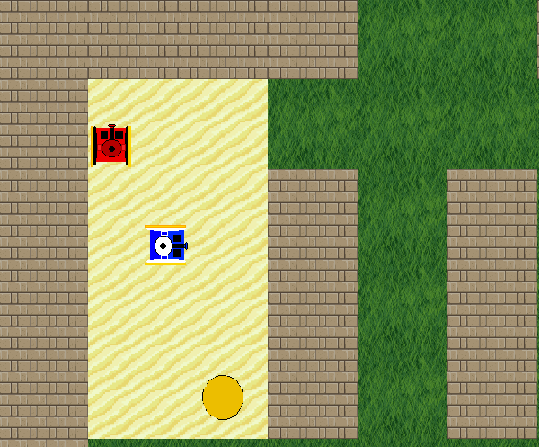Second, I planned on having the player have a mine option, but found this too complicated to integrate into my new design with the warship battle. I had to tinker with movement and missile speeds a lot to make the game exciting, which was the most insightful part of this development process for me. Having variables that are not hard-coded makes code much more legible and able to be cleverly manipulated. I had my roommates as my main play-testers to find this happy balance. Also, adding the component to have the score constantly drop while the player fights helps to show that it is largely about time for high scores.

Specific Element: I specifically added the score/display elements, warship NPC, missile class, and laser class for this project. It was a lot of work by myself but I am proud of the result.

**Credits:**

Besides the warship and castle wall sprites, all sprites were handmade by me using the online Piskel app available at: <http://www.piskelapp.com/>

Castle tiles : <https://s-media-cache-ak0.pinimg.com/originals/78/6a/6c/786a6cb61f8db8142de9f15639f4ecd2.jpg>

Warship taken from spritesheet found on this forum post: <http://fractalsoftworks.com/forum/index.php?topic=11002.0>

